

## Topic: Refreshing the Acknowledgement Queue

When you select a document to acknowledge, once you have clicked the **Acknowledge** button, the button goes away and theSource will remain on the document. However, if you have additional documents to acknowledge, a **Next** button will display in the same location on the screen, allowing you to move to the next acknowledgement in your queue by clicking **Next**.

But did you know you can easily return to your Acknowledgement queue by clicking on theSource icon after acknowledging a document?

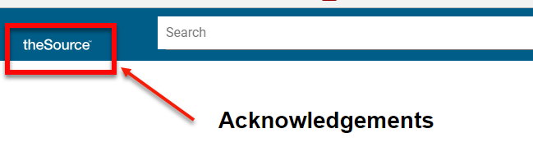

When you return to your queue after performing each acknowledgement, you will notice that theSource has removed the acknowledged document from the list and the total number of documents remaining will be adjusted to reflect the new total.

**Note:** Refreshing your queue can also be done within the Acknowledgement window.

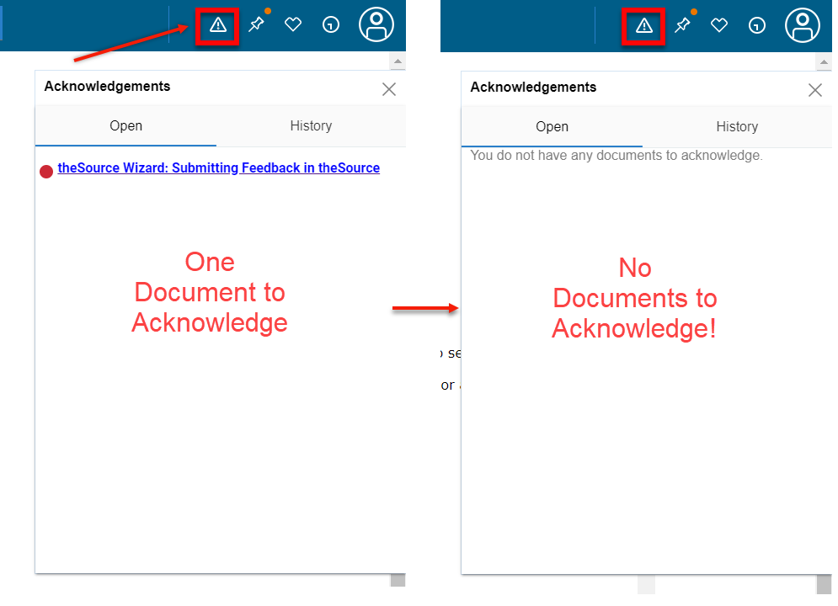

 Your next challenge on the quest to becoming a Certified theSource Wizard is to use one (or both!) of the options above to refresh your Acknowledgement queue.

Additional resources:

Become a Certified theSource Wizard: Index

Not to Be Reproduced or Disclosed to Others without Prior Written Approval

**ELECTRONIC DATA = OFFICIAL VERSION / PAPER COPY = INFORMATIONAL ONLY**